Memo Redraw Fig5 with beta=4, Kd=Km=Ka=0.1 At=0.3

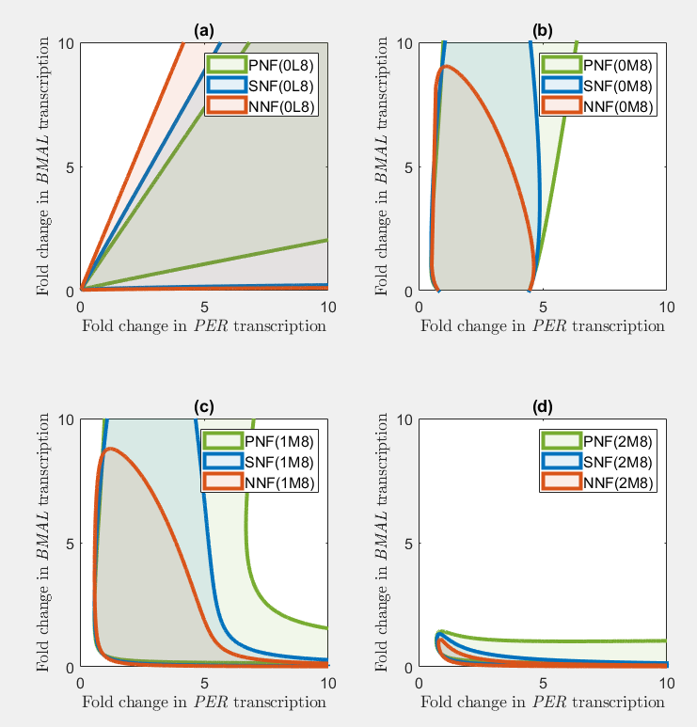

Investigate the circadian period of 1M8 models in Fig4.